**Level Design Document**

Level Design 1920_COMP08092_01

Post Apocalypse

**Team Members**

Conor Haining (B00358028)

Stuart Watt (B00359799)

Mohammed Ibrar (B00348058)

Gabor Juhasz-Hartmann (B00348029)

University of the West of Scotland

Paisley Campus

1. **Design**
   1. Narrative

The narrative of our level takes inspiration from many other games such as the last of us, resident evil. Our protagonist finds themselves in a hostile city environment and must use his cunning to escape the danger of the city streets. An ominous militaristic force has taken control of the area and the protagonist must find a way to circumnavigate them. The city is however full of danger and the protagonist is not safe there so he must find his way out his best chances are to use the cover of dusk to navigate the maze of side alleyways and devastated buildings.

* 1. Setting/Theme

1.2.1 Setting

Our game is set in Post-Apocalyptic Boston, Massachusetts in America after a deadly virus has wiped out a large portion of humanity. We have chosen this location due to the wide streets and unique architecture, as we wanted to create an Urban environment that could be both spacious and claustrophobic as players navigate from section to section of the level.

1.2.2 Location

The specific area of Boston this game is exploring is Downtown Boston itself, the reason we specifically chose this is due to the fact we wanted to create an urban environment while still having the opportunity to place wildlife and foliage in places to give a greater sense of nature reclaiming society, we also wanted the player to be able to go through claustrophobic areas like Alleyways and large open areas like parks as we can use this variety in space to create unique and tense moments. The urban area also allows for us to have the players go through buildings and also interact with other survivors as humanity would likely still be condensed in certain areas. We also like this setting as it allows us to make good use of lighting to create a tense and atmospheric setting.

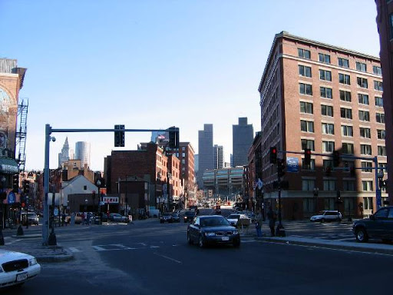

*Screenshot of Boston Streets as location reference*

1.2.3 Theme

The game is set around 10 years in the future, after the collapse of modern society. The level will be set in the evening which means we can use lighting in various ways to create atmosphere for the level, we will also make use of fog to obscure visibility for both the player and AI.

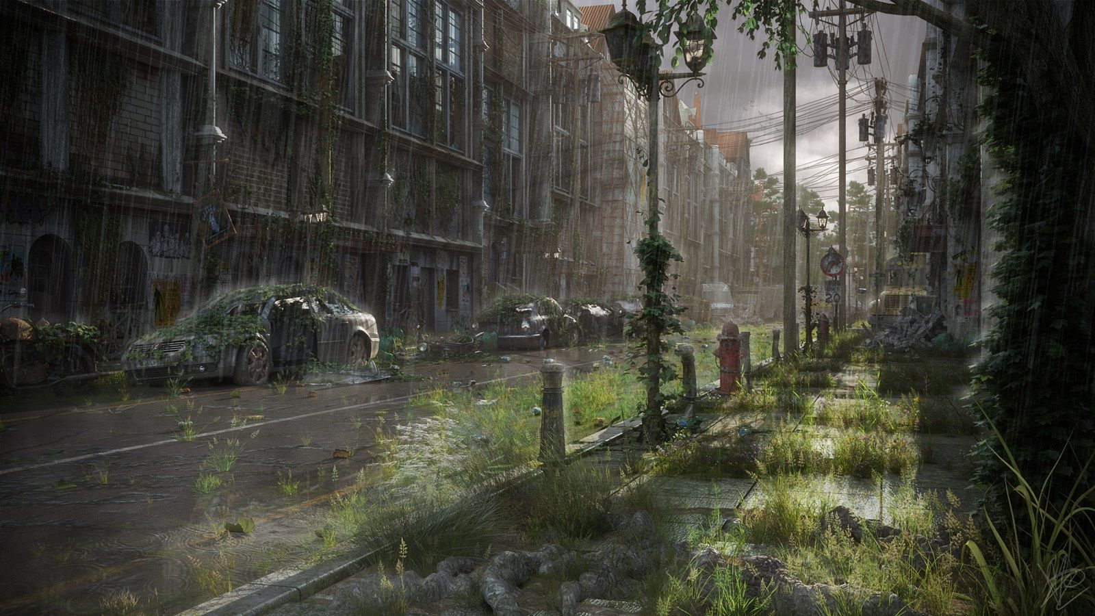

*Post-Apocalyptic Theme reference*

1.2.4 Focal Points

As the player progresses through the level they will have to pass through or by several small ‘Landmarks’ to help guide their progression. The game itself is quite linear in terms of getting from start to finish, but these landmarks will help give the player a better sense of direction and where they are required to go next. Our first major area after the player leaves the alleyway will be a store that the player will need to traverse through, initiating in combat with several AI survivors in order to make it through the building. After making it through this building the next landmark area is a public park where the player will need to find a ladder and place it against a wall on the opposite side of the park in order to progress to our final main area which will be an abandoned factory district. We will place a unique building at the end of the level to signify the player’s final destination, and we will attempt to have this final location visible to the player from the main street the player starts on.

1.2.5 Space

For our game, the space the player has to navigate around the level has been an important focus for us as it is integral to creating an atmospheric and realistic environment for our player to traverse and interact with. We are exploring different uses of verticality in the level so that at times the player may have a height advantage or disadvantage against opponents he faces, and so that everything has a sense of realistic scale within the world.

The player will start the level in a confined alleyway space intended to set the initial atmospheric tone of the game, before moving onto an open street where there will be multiple enemies for the player to either stealth past, or initiate combat with, from there, the player will navigate through an open building with multiple rooms where they will again have to fight off multiple enemies. We are deliberately moving the player from claustrophobic spaces into open ones and then back into claustrophobic spaces to give the player a sense of unease, areas of the level will also be highly dense in objects to provide the player cover, whereas others will be open and therefore more dangerous for the player to traverse across without taking damage.

* 1. Player Experience

As far as player experience is concerned, the overall feeling that we want the player to experience is the feeling of dread, despair along with a sense of nostalgia. As it is set 10 years in the future, the old remnants of what was once a civilised society can immediately be felt by the player and this really puts into perspective the damage that has been caused by the deadly virus. Modern society no longer plays a vital part in the player’s day-to-day life and this is evident in the props used for the level. The player will be determined to reach his destination of the district factory whilst either avoiding the enemy AI and sneaking past them of engaging in direct combat with them. The theme of the level will keep the player motivated as the apocalypse has already begun and survival is the main instinct on the player’s mind, no matter what the cost.

* 1. Level Features

The following is a list of features that the level will incorporate in order to create an interesting and fun experience for any user, and those that will attract the user to return and experience the level again:

* A visually detailed 3D environment created in Unity
* Realistic graphics to resemble the streets of Boston, Massachusetts
* Third person control of the player, with the ability to walk and crouch
* Interaction with the props (e.g. ladder which the player must climb)
* The ability to choose which type of gameplay to experience, for example, stealthily walking by enemies will result in a quieter and stealth-based approach whereas engaging with the enemy will result in a fast-paced action type game
* A wide range of streets, from tight alleyways to open areas
* A sense of realism
* Interaction with an object, without which, the player cannot proceed to the final scene
  1. Design Typology
  2. Gameplay Reference and Research

For our game we have drew inspiration from different mediums of media such as books, games, and movies, from our list of inspirations, these are the titles from each field that we consider most relevant to our game.

**The Last of Us**

The Last of Us is arguably one of the biggest and greatest games created in the entire history of gaming. The game follows the post-apocalyptic story of Joel, a man who has survived through a zombie outbreak and has lost everything to the point of trusting no-one, and Ellie, a young girl who may be the cure to the zombie plague that has fractured mankind to its core. We draw similarities to The Last of Us through our use of urban environments, our post-apocalyptic setting and through the third person perspective we have chosen for our level.

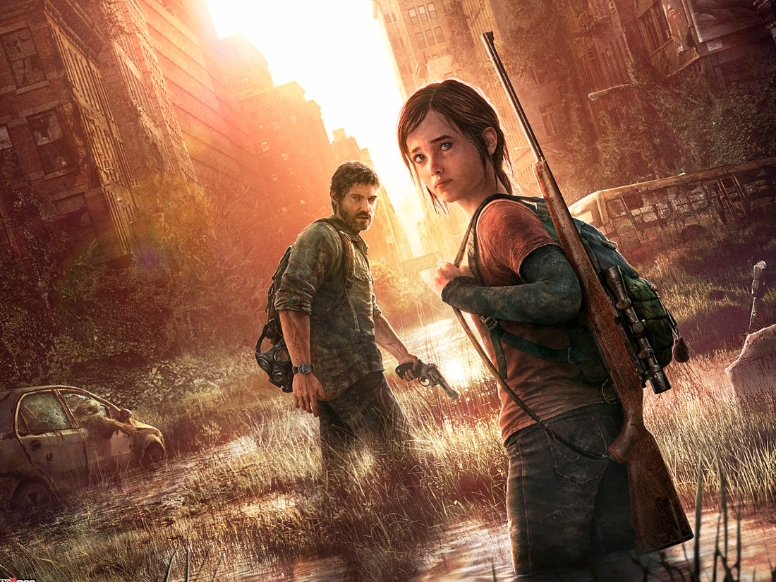

*The Last of Us*

**The Road**

The Road is a post-apocalyptic movie set in America following a man and his son wandering across a post-apocalyptic environment trying to keep civilization alive while trying to avoid roving gangs of savage humans and cannibals. We draw inspiration from this movie due to the post-apocalyptic, dismal and atmospheric setting.



*The Road*

* 1. Photo/Video Reference and Research

1.7.1 Architecture

The level is set in North America, specifically Boston, Massachusetts, and as such we will aim to stick as close to this as possible. The architecture of Boston is a mix of Colonial-style architecture, Georgian architecture and Federalist architecture, and as such there is a large mix of older high-rise buildings consisting mainly of grey or brown brick, and some more modern architecture with glass panelling. Some of the older buildings feature Greek style pillars as a feature of their architecture.

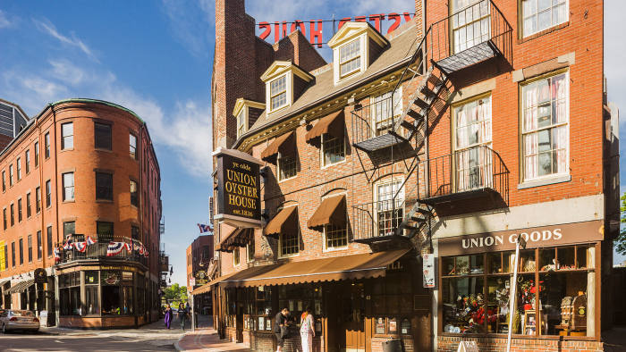

*Boston Architecture Reference*

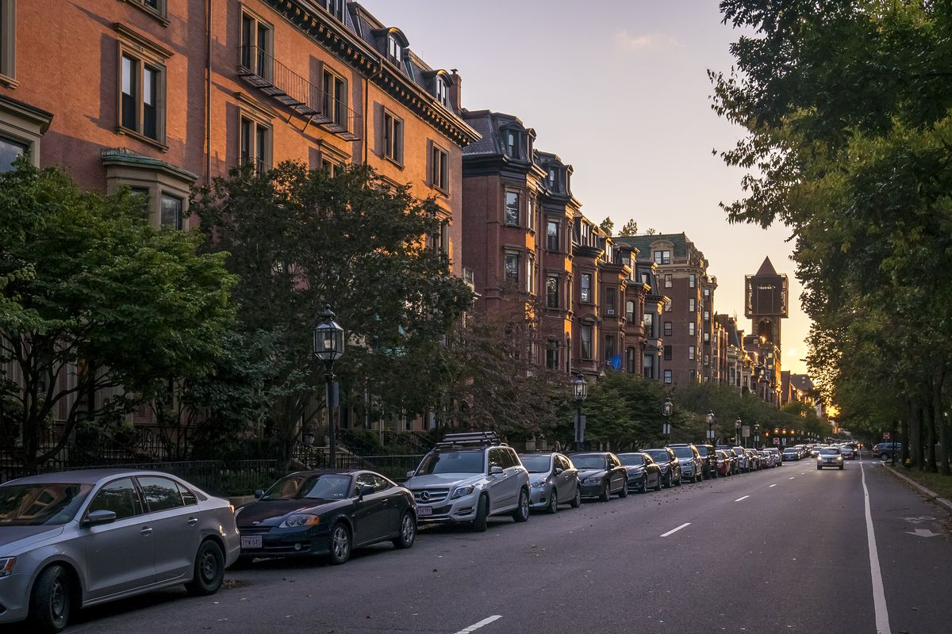

*Boston Architecture Reference*

1.7.2. Props

For this level we will be using props that you would mostly find readily available

in an urban environment to keep a sense of immersion and realism, they will also be used to give the player cover in certain situations along with filling out the otherwise empty locations with a variety of objects to add depth and interest to the level. Some of the objects that we will use is as follows:

* Construction Equipment
* Crates and Barrels
* Rubble from Bricks and Trash
* General litter such as Newspapers and Cans

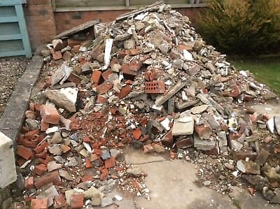

*Rubble Prop Reference*

* 1. Story

The player takes on the role of the protagonist Joe local tv news reporter who was traveling to a local hospital to report on a breaking news story regarding a sudden viral epidemic. While making his way to the hospital the whole city was placed under emergency lockdown and a sinister military presence enforced martial law on the city streets blocking off whole sections of the city both evacuating many people and trapping many more inside their homes and workplaces.

A few days in and Joe has yet to find proper refuge the city appears completely abandoned save for the sinister guards who have recently become far more hostile to the few remaining people Joe knows he must find a way out of the city if he is to survive.

* 1. Interactivity
* Objectives

The main objective for the player will be to get through the level to the end point to escape that part of the city. To achieve this the player will have to manage their health, enemies as well as overcome interactive light puzzle sections making use of the games mechanics of sneaking shooting and interacting with specific objects.

In our level we are aiming to have multiple objectives the first of which will be the collection of a gun which will serve as the players main source of interaction with enemies as well as interaction with some light puzzle sections such as shooting locks.

Another objective the player will have during the level will be to take a ladder over to a progression point to venture further into the level. The player will be required to interact with the ladder to obtain it then interact with the spot they need to climb.

* Obstacles

The main recurring obstacle in our game will be enemies the main ways the player will be able to overcome this is with the use of a stealth mechanic allowing them to sneak past enemies so long as they don’t have direct line of sight of the player. Use of crouching and deliberate movement will be the key to this mechanic.

The player will also have access to a gun which they can use to eliminate enemies although we are aiming for this to be a supplementary mechanic to the stealth so that levels will mainly involve sneaking rather than shooting.

* Set Pieces/Scripted Events
  1. Visual Development
* Style Reference

Our main reference for visual aesthetics is the last of us we want our game to have a similar visual feel of post apocalyptic that doesn’t solely focus on dense urban areas but also incorporates wildlife and garden areas.

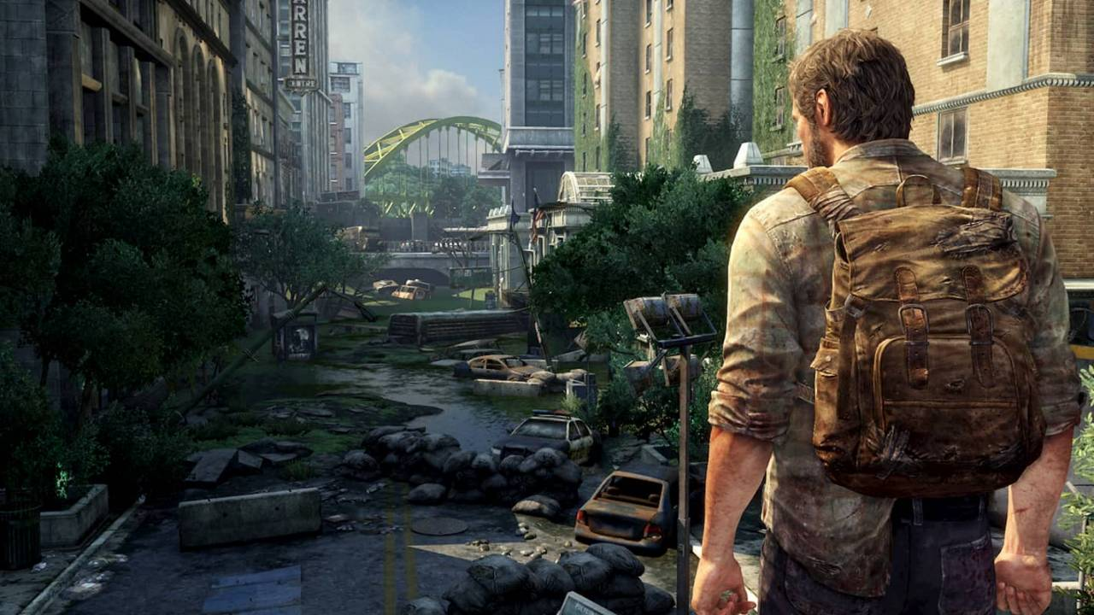

Another influence for our visual theme was Resident evil 2 we wanted to replicate the dark atmospheric lighting as well as its tight claustrophobic alleyways that created a sense of unease and tension which lends itself well to the type of level mechanically we wish to create.

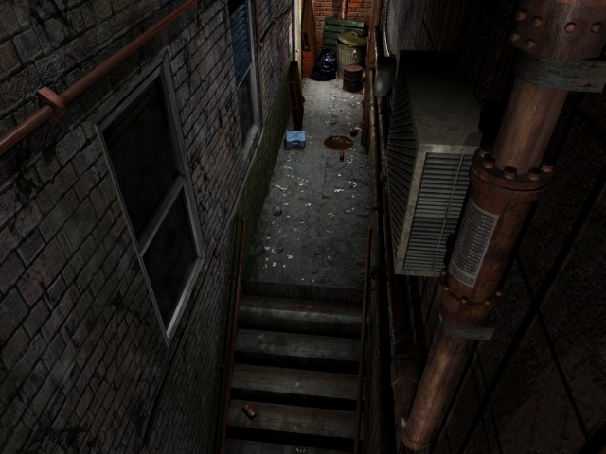

* Colour Palette

For our colour scheme we wanted to incorporate mostly urban colours reminisant of towns and citys in America. The buildings being red bricked with black trim and pavement being white paved stone the palette is a mix of light and dark colours meant to accurately represent an urban street with stark contrasting reds and yellows coming mainly from signs and mechanical equipment such as generators.

We plan on having garden areas that will provide much needed break in colour from quite gritty and bleak streets with strong greens and more stark colours of flowers and fauna our aim is to just represent a diverse urban area in which inhabitants would have access to more environmental garden areas.

* Lighting

Lighting is an important part of our level both from a visual perspective as well as a mechanical we feel it is important for the sake of grounded gameplay that the character is moving stealth fully around in as a believable way as possible. To this end the level will be set dusk providing the low light levels to make the narrative of the players actions sensible.

We also believe that using a lower ambient light level will provide our level with the visual appeal we are looking for of a worn-down city and feeling of unease that an empty city with little life gives.

* 1. Top-Down Layout and Concept Art

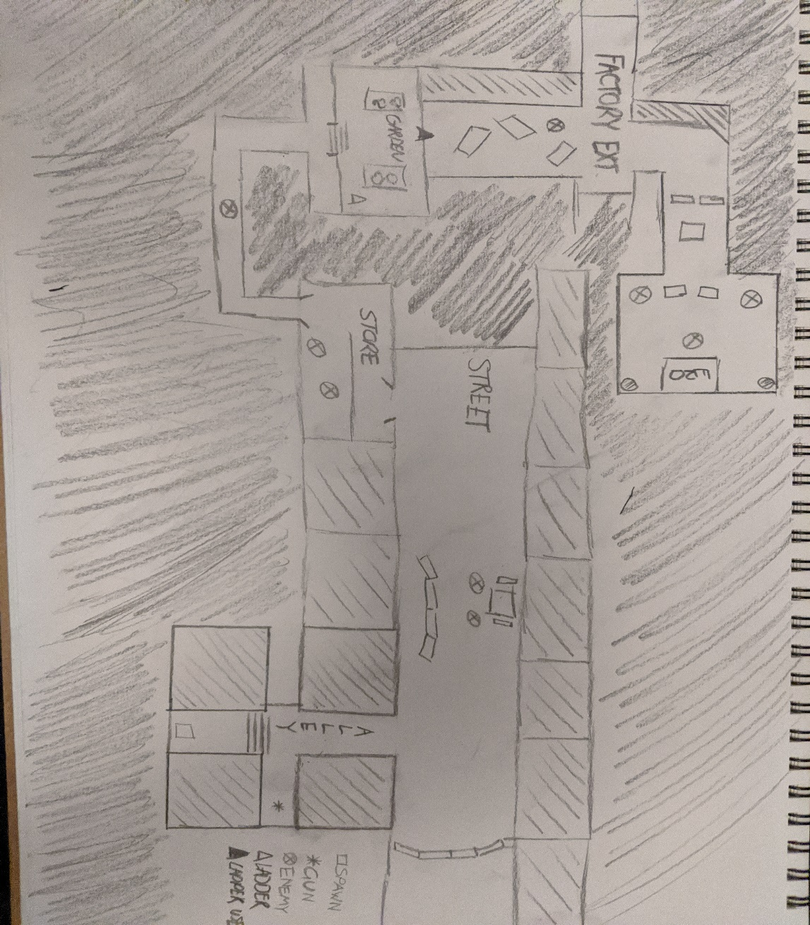

*Top-Down View of Map*

The top-down schematic drawing of the level has been produced in order to visualise what the level is going to look like. From this, we can get a clear image of the playable level and its’ functionalities. This shows the street which the player will walk upon including any props and dead-ends that the player might run into. It also shows other features of the level such as a store and garden, and also an exit point. A key has been included to indicate the player’s spawn point, a gun, the enemy and the upper section of the level where the player will ultimately end up in order to complete the level.

* 1. Uniqueness/Originality of Level

For the creation of the game we are using a modular building pack with several hundred pieces of static meshes, meaning that the buildings that we will use are not repeating, and are unique on their own.

](file:///D:\UWS%20Uni%20Folder\Year%202\Level%20Design\unnamed.gif)

The game will have different looking areas (Alleyway/Street/Store/Garden/Factory Exterior) with different approaches to complete the level segments. (Stealth, Combat, Puzzle)

Each area will contain specific landmarks and focal points which will show the player where to go in order to advance in the level.

The enemies will have a basic AI, that have a line of sight and will attack the player upon detection.

1. **Project Planning and Control**
   1. Project Plan

For the project plan, the 4 group members of this team kept in touch via Discord. This was set up on day 1 of the class when the assignment was handed out. This allowed us to communicate and allocate tasks regarding the project. In order to work efficiently, and to meet the set deadlines we got to work straight away and planned our level. We had decided that the tasks would be split up as follows:

|  |  |
| --- | --- |
| **Team Member** | **Tasks** |
| Conor Haining | Creating exterior for the level, utilising the use of assets to create the environment |
| Mohammed Ibrar | Working on the blueprint for the movement and shooting |
| Stuart Watt | Working on the interaction functionality with the ladder and AI |
| Gabor Juhasz-Hartmann | Creating the interior for the level, utilising the use of assets to create the interior. |
| Everyone | Documentation |

* 1. Estimated Duration
  2. Tasks and Sub-Tasks
  3. Allocation of Tasks
  4. Progress Monitoring
  5. Version Control

1. **Playtesting**

To Test our level we are going to implement blackbox, whitebox testing. During the production of the level we are going to implement whitebox testing allowing us to simultaneously implement features and assets as well as test their functionality. Primarily we will be testing for any major issues regarding level progression and completion, interactivity issues mainly involving enemies and key objects within the level.

We will undertake whitebox testing ourselves individually and communicating the results to each other while documenting them. We will be taking into account what feature we are testing, what we expect as an outcome, what the actual outcome is after executing the test, did the outcome align with our expectation and the action we intend to take.

These tests will be made throughout the development process as we implement new elements to our level an example of this process would be in the implementation of a door with the expected outcome being it allowing the player to pass through it once interacted with and if this test produced an effect that did not allow the player to pass through it the door would be reassessed and tested again.

For the Blackbox portion of our testing method we will make a short online survey which we will send to our level testers along with the level. The aim of this survey will be to assess the level in areas and aspects relating to the player experience gaining valuable feedback on how easily navigatable the level is, how readable objects and objectives are as well as if there was any bugs encountered by the tester and the process required to reproduce them.

Our demographic is mainly aimed at the 18-25 age range so our level testers will consist of people within that age bracket. We are also planning on finding testers with varying degrees of game knowledge and understanding to broaden our test results.

Testers will consist of individuals we both know and do not know personally as either friends, colleagues or family members to this end we plan on asking university students for participation in our levels testing. These testers will have no prior knowledge of our level its layout or design and will have no input from team members while playtesting or answering the survey.

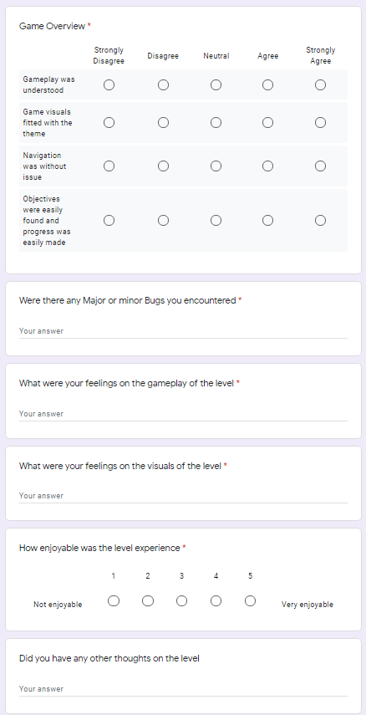

This is a draft of what our survey will look like with some of the questions we will ask to our play testers.